/* Samuel Greenlee */

/* SQL Server */

/* Use Statement for SamsCarsSGG Database */

Use SamsCarsSGG;

/* Not View */

Create View EnginesNotV6

As

Select *

From Engine

Where Not Engine_Type = 'V6';

Select * From EnginesNotV6;

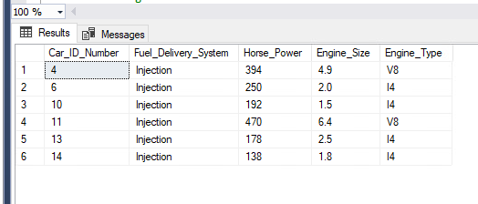

/* Aggregate Function, Group By and Having View */

Create View EngineSizeDifference

As

Select Car_ID_Number, Fuel_Delivery_System, Horse_Power, Engine_Size, Engine_Type, SUM(6.0 - Engine_Size) as 'Size_Difference'

From Engine

Group By Car_ID_Number, Fuel_Delivery_System, Horse_Power, Engine_Size, Engine_Type

Having Engine_Size < 6.0;

Select * From EngineSizeDifference;

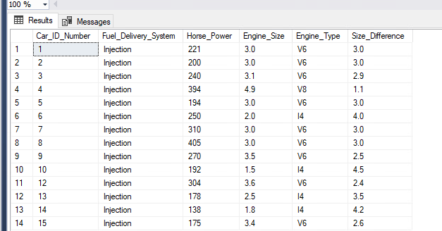

/* Inner Join View */

Create View CarEngineTypeMatch

As

Select c.Car_ID_Number, Year_Made, Make, Model, Drive_Train, Date_Added, Engine_Type

From Car as c

Inner Join Engine as e

On c.Car_ID_Number = e.Car_ID_Number;

Select * From CarEngineTypeMatch;

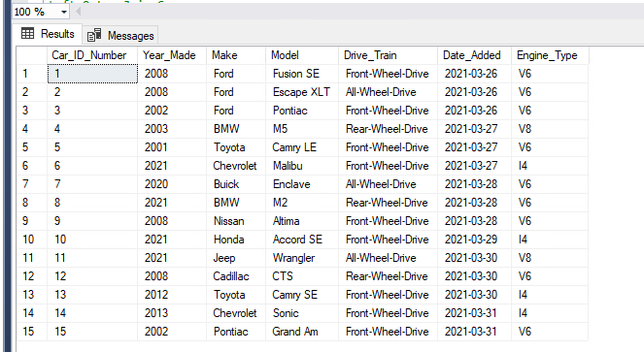

/* Outer Join, AND, WHERE View */

Create View UnusedEngines

As

Select e.Car_ID_Number, Fuel_Delivery_System, Horse_Power, Engine_Size, Engine_Type, Year_Made, Make, Model

From Engine as e

Left Outer Join Car as c

On e.Car_ID_Number = c.Car_ID_Number

Where Year_Made Is Null AND Make Is Null AND Model = Null;

Select * From UnusedEngines;

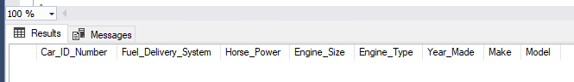

/* Subquery View */

Create View CarsWithI4Engines

As

Select *

From Car

Where Car_ID_Number IN (

Select Car_ID_Number

From Engine

Where Engine_Type = 'I4'

);

Select * From CarsWithI4Engines;

